Лабораторная 7

1. ICMP Protocol Analysis (Ping)
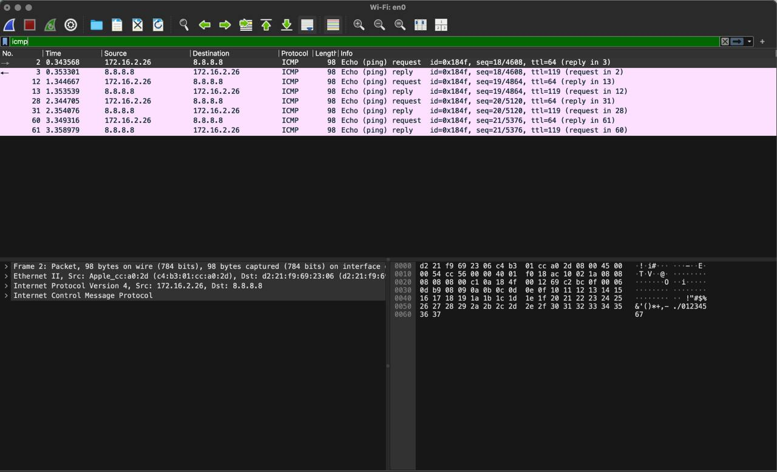
• Task: Capture ICMP traffic and identify message types.
• Analysis: Captured traffic during the ping 8.8.8.8 command.
• Details:
• Source IP: 172.16.2.26
• Destination IP: 8.8.8.8
• ICMP Type 8 (Echo request): Initiated by the local host to check connectivity.
• ICMP Type 0 (Echo reply): Received from the remote server, confirming the path is active.

2. DNS Protocol Analysis (Domain Name System)
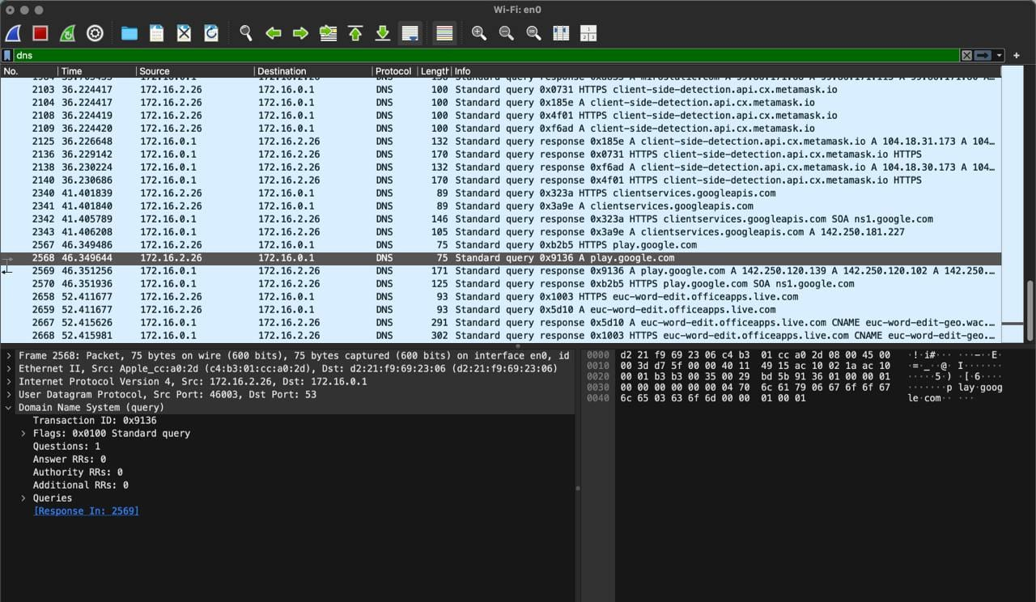
• Task: Identify DNS query and response for a web resource.
• Analysis: Captured the resolution process for play.google.com.
• Details:
• Query: Standard query A play.google.com (Requesting the IP address).
• Protocol: UDP (Port 53).
• Response: The DNS server returned the corresponding IPv4 address.

3. TCP Protocol: 3-Way Handshake
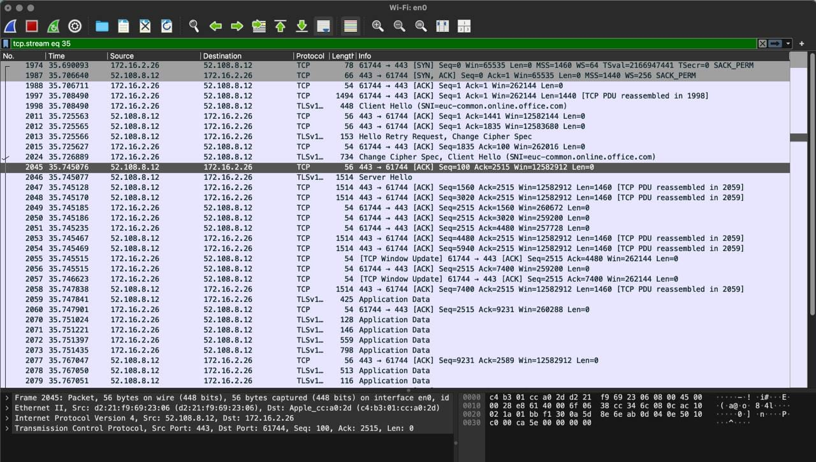
• Task: Capture the connection establishment process.
• Analysis: Analyzed the start of an HTTPS session with the server.
• Handshake Steps:
1. [SYN]: Client sends a synchronization request.
2. [SYN, ACK]: Server acknowledges the request and sends its own sync.
3. [ACK]: Client confirms the connection. The session is now open for data transfer.

4. TCP Protocol: Connection Termination (FIN)
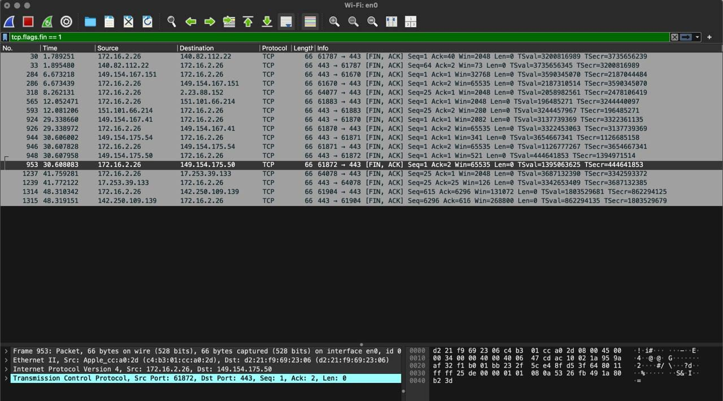
• Task: Capture the session closure.
• Analysis: Filtered the traffic for the FIN flag to find the end of the session.
• Details:
• Packet Flags: [FIN, ACK].
• Logic: One of the sides initiates a graceful shutdown of the connection, which is then acknowledged by the other side.

